
Name: Janushiya P A
Reg No: 1924260368
Course Code: CSA0224
Course Name: C Programming

TASK 10 – Compare Expectations with Execution

1. Aim
To compare the expected and actual behaviour of data types and constants in the electricity-billing program, including floating-point accuracy, integer overflow, storage sizes, and district-level bill totals.

2. Float vs. Integer Paisa Totals
For this example, assume every bill is ₹0.10. The exact total is calculated by multiplying the number of bills by 10 paisa.
Number of bills | Exact total | Float total (approx.) | Difference
4,000 | ₹400.00 | ₹400.0152 | ₹0.0152
60,000 | ₹6,000.00 | ₹6,003.5059 | ₹3.5059
800,000 | ₹80,000.00 | ₹80,645.8438 | ₹645.8438
These are illustrative results from repeatedly adding the single-precision float value 0.10. They are not measurements from my computer.
The float total becomes less accurate as the number of additions increases because many decimal fractions cannot be represented exactly in binary floating-point. Integer paise gives exact totals for these amounts: 4,000 bills = 40,000 paise, 60,000 bills = 600,000 paise, and 800,000 bills = 8,000,000 paise.
3. Integer Overflow at District Scale
Overflow occurs when an integer calculation exceeds the range of its data type.
- int: May overflow if the total exceeds its maximum value. A 16-bit int cannot store 8,000,000 paise, but a typical 32-bit int can.
- long: A typical 32-bit or 64-bit long can store 8,000,000 paise.
- long long: A typical 64-bit long long can store this total comfortably.
Therefore, the actual result depends on the system's type sizes and the size of each bill. Signed integer overflow in C is undefined behaviour, so it must be prevented.

4. Size of and C Standard Minimums
The C standard does not require every computer to use the same number of bytes for each integer type. It guarantees minimum ranges, while actual sizes depend on the implementation.
Data type | Minimum guaranteed range
int | At least −32,767 to 32,767
long | At least −2,147,483,647 to 2,147,483,647
long long | At least −9,223,372,036,854,775,807 to 9,223,372,036,854,775,807
The size of operator and the limits.h header can be used to check the actual sizes and ranges on my system. These results should be compared with the minimum guarantees of the C standard.
Coding
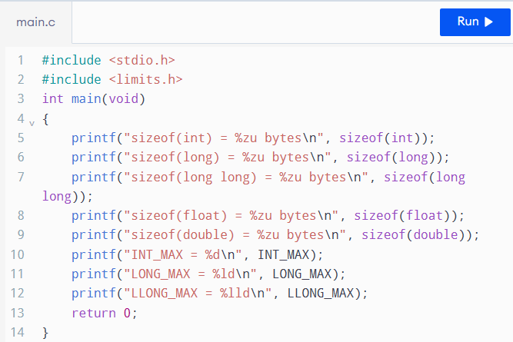

Output
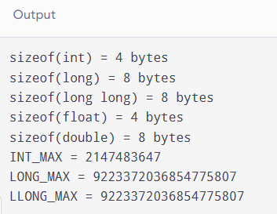

5. Alternative Concept: Using double
Using double instead of long long avoids integer overflow for many large totals, but it does not guarantee exact representation of decimal fractions such as ₹0.10. Repeated additions can introduce small rounding errors.
For 800,000 bills of ₹0.10, double precision typically gives a result extremely close to ₹80,000.00, while integer paise give the exact total of 8,000,000 paisa, provided the integer type has sufficient range.
For fixed-size types, each addition takes constant time, O(1), and each variable uses constant space, O(1). A double often occupies 8 bytes and a long long often occupies 8 bytes on modern systems, but actual sizes must be checked using size of.

6. Conclusion / Result
The comparison shows that integer paise is suitable for accurate monetary calculations, while floating-point totals may accumulate rounding errors. The choice between int, long, and long long must depend on the required range and the system's actual type sizes. Using sizeof, limits.h, and measured program outputs helps verify that the billing program remains reliable when processing large numbers of households.

